Water Board Assembly Guide

MIT CityFARM

These are instructions on how to assemble a Water Quality Sensor Board using various water quality sensors, which communicate through a serial connection, and a Raspberry Pi.

For this example, 5 sensors will be used, and one Raspberry Pi, as well as an IP66 rated polycarbonate box to house the sensors and Raspberry Pi.

**Parts and equipment needed:**

* Sensors (Links to suppliers provided at the reference section):
* Atlas Scientific ENV-TMP-D Digital Water Temperature Sensor [1]
* Atlas Scientific pH circuit [2] and probe [3]
* Atlas Scientific ORP circuit [4] and probe [5]
* Atlas Scientific DO circuit [6] and probe [7]
* Atlas Scientific EC circuit [8] and probe [9]
* 4 Atlas Scientific Isolator circuits [10]
* 5 USB-Serial/TTL converters [11]
* Raspberry Pi model B+ [12]
* Suitable waterproof polycarbonate box [13].
* 2 1.85 X 7.05” perfboards [14]
* 20 M2.5 3mm screws
* 10 M2.5 4mm nylon standoffs
* DXF file supplied (CAD file included) [15]
* Access to a Laser Cutter.
* Soldering Iron.
* Wires.
* 4 BNC connectors (Comes with the Atlas Scientific circuits used)
* 8 3-pin 0.1” pitch headers, 8 7-pin 0.1” pitch headers
* 1 4-pin 0.1” pitch screw terminal.

Steps:

1. Solder headers to perfboard.

Solder all the 3 pin and 7 pin headers in the following fashion, ensuring that they are properly spaced and aligned, so the circuit isolators and circuits can fit:

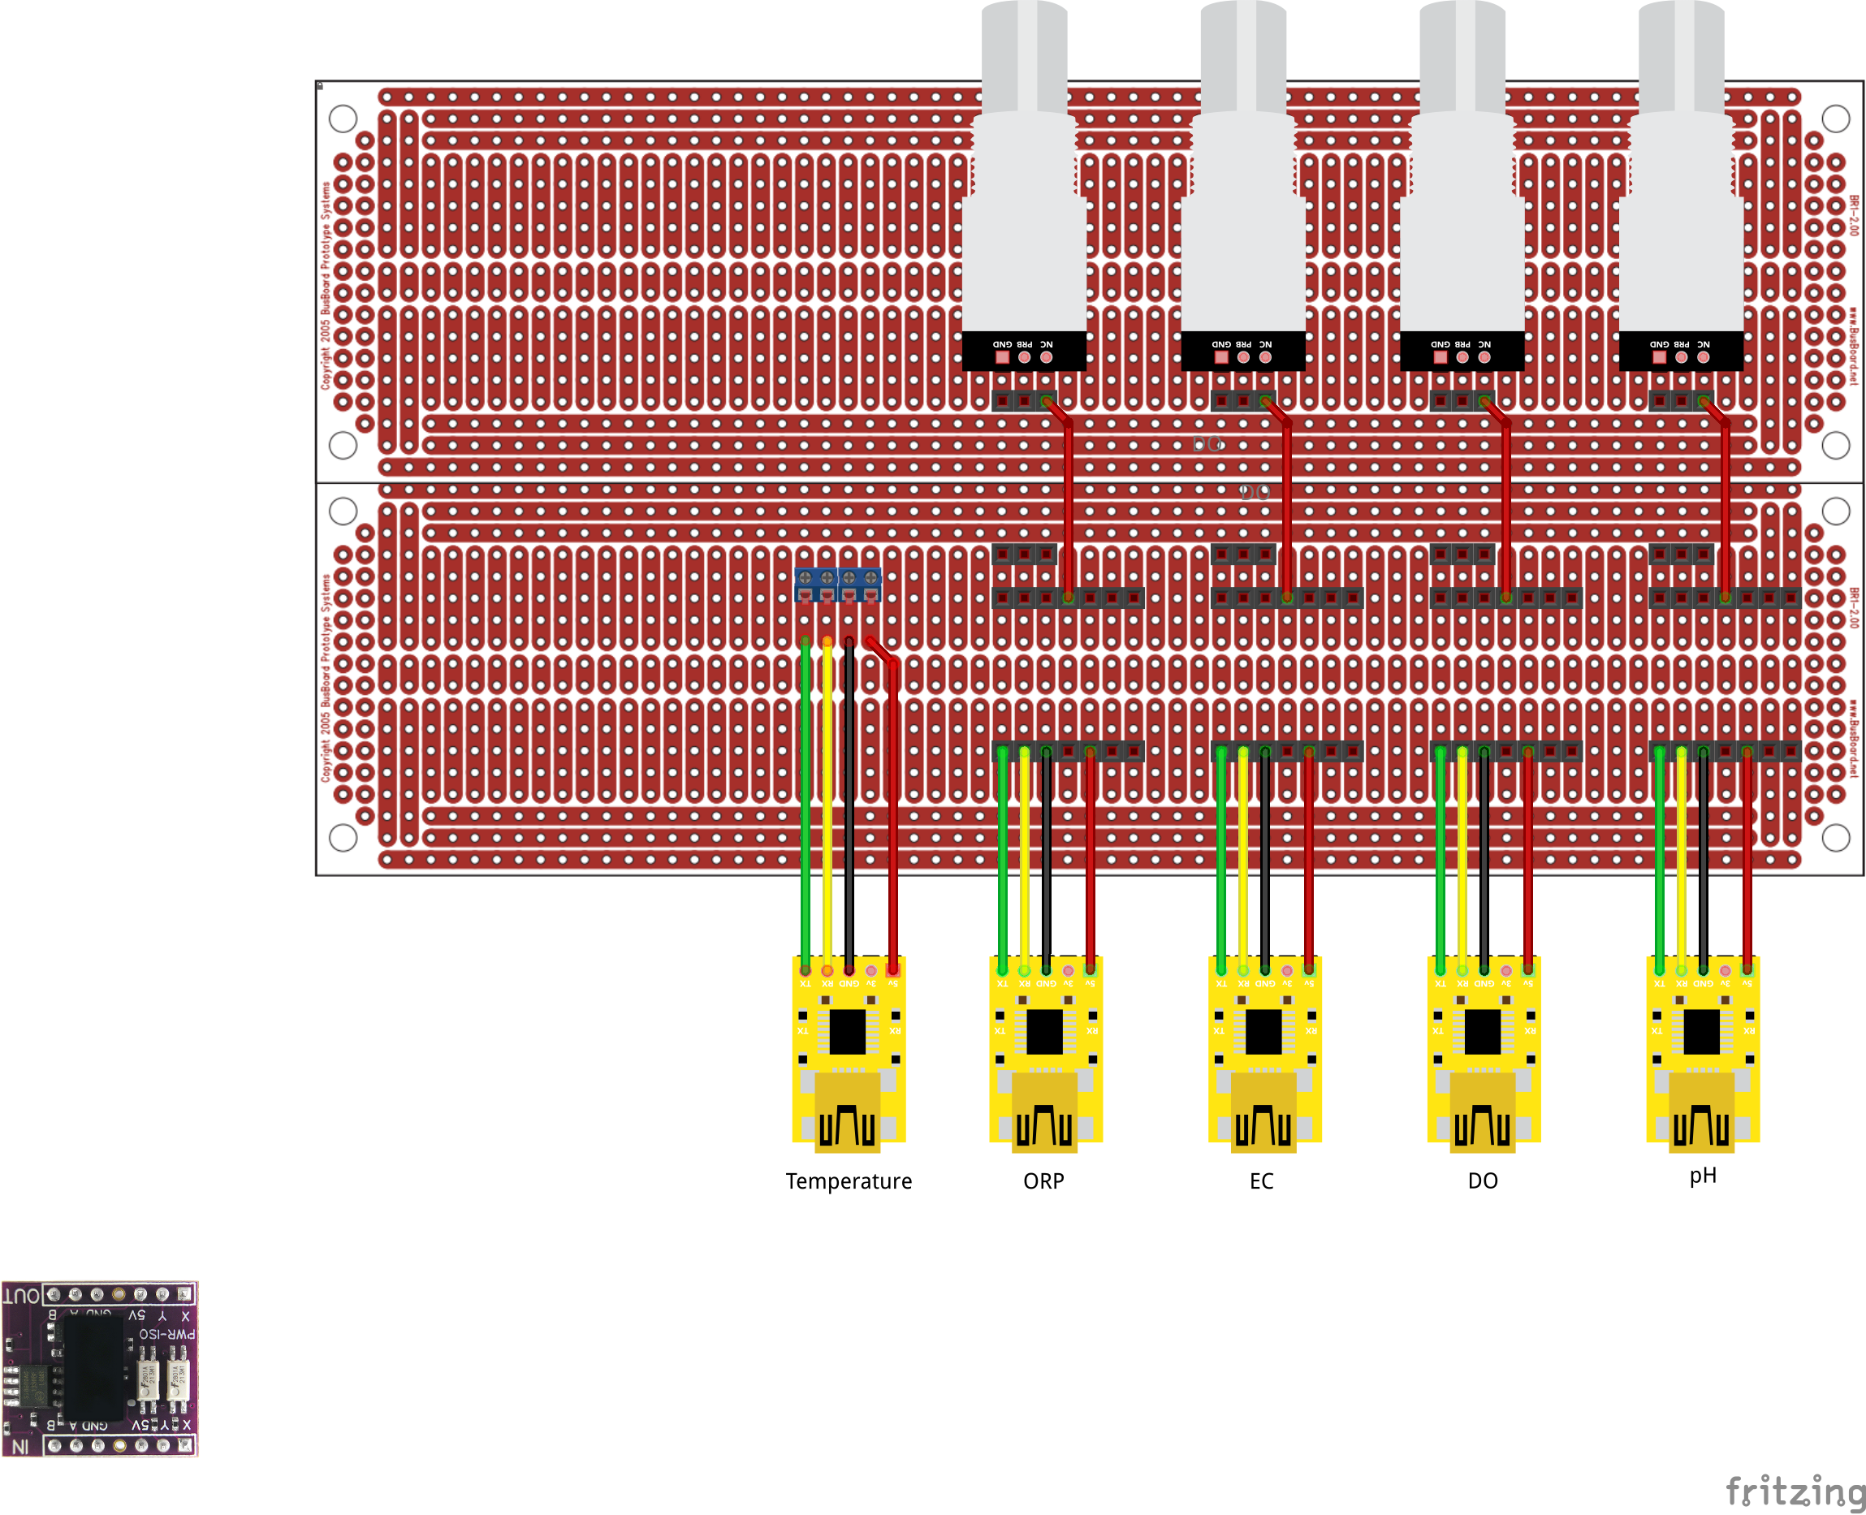

BNC connectors

Circuit headers

5V jumper wire

Power isolator headers

USB-Serial converters

Notes:

* The power isolators isolate each sensor, so they do no interfere with each other. The output serial connection and power are isolated from the input.
* There is a jumper wire to connect the 5V output from the power isolator (upper 4th pin from left to right) to the VCC pin on the circuit (upper 3rd pin from left to right).
* The temperature probe connects directly to the USB-Serial through a screw terminal.

Board with circuits and power isolators attached:

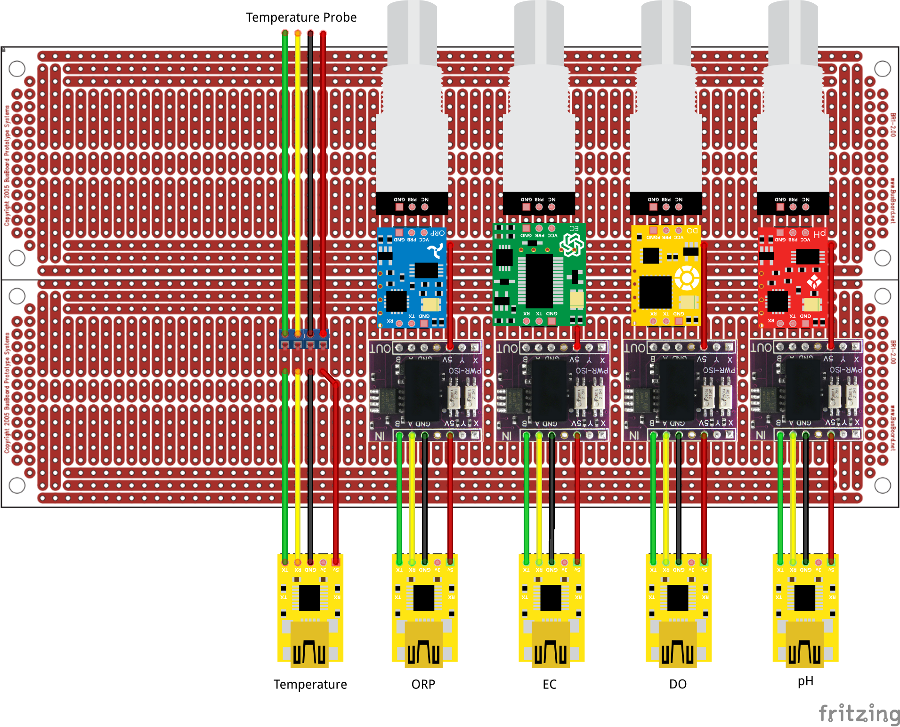

Schematic:

Macintosh HD:Users:gkolotelo:Documents:Programming:University:MIT:CityFARM:images manual:For-Guide:WB.PDF

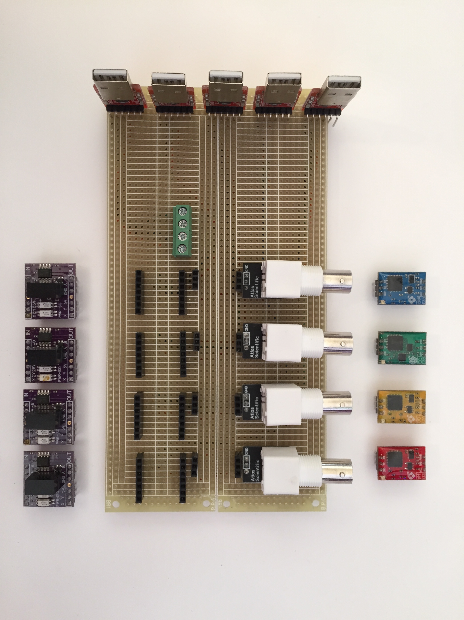Example:

Headers:

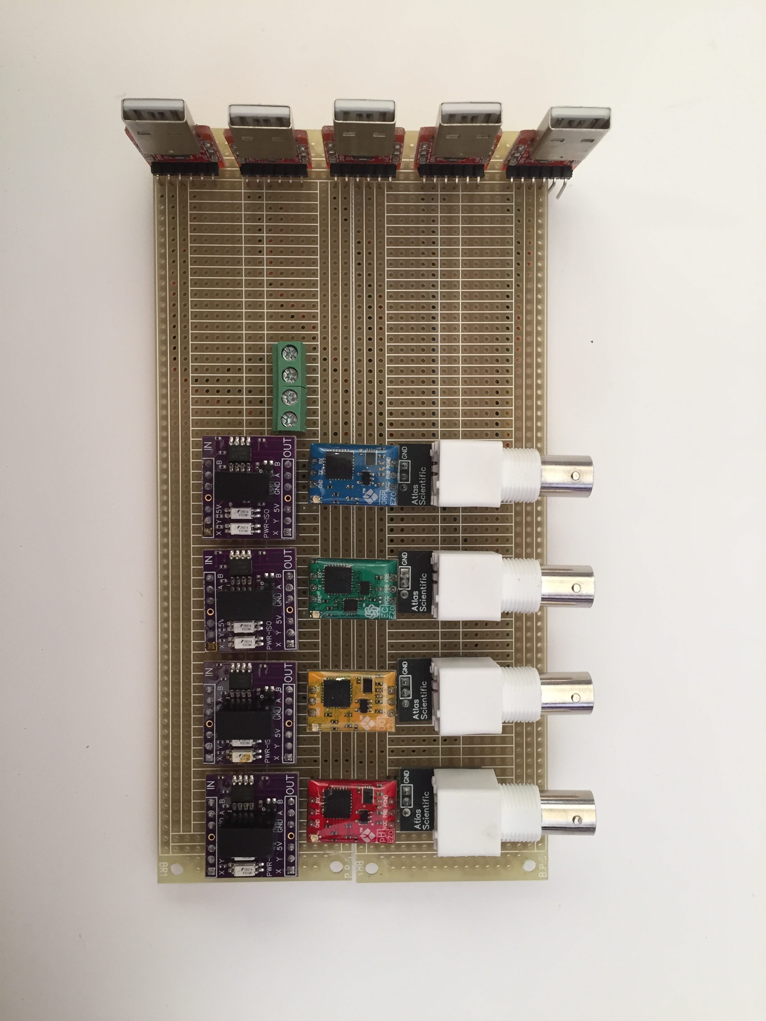

Circuits and power isolators plugged in:

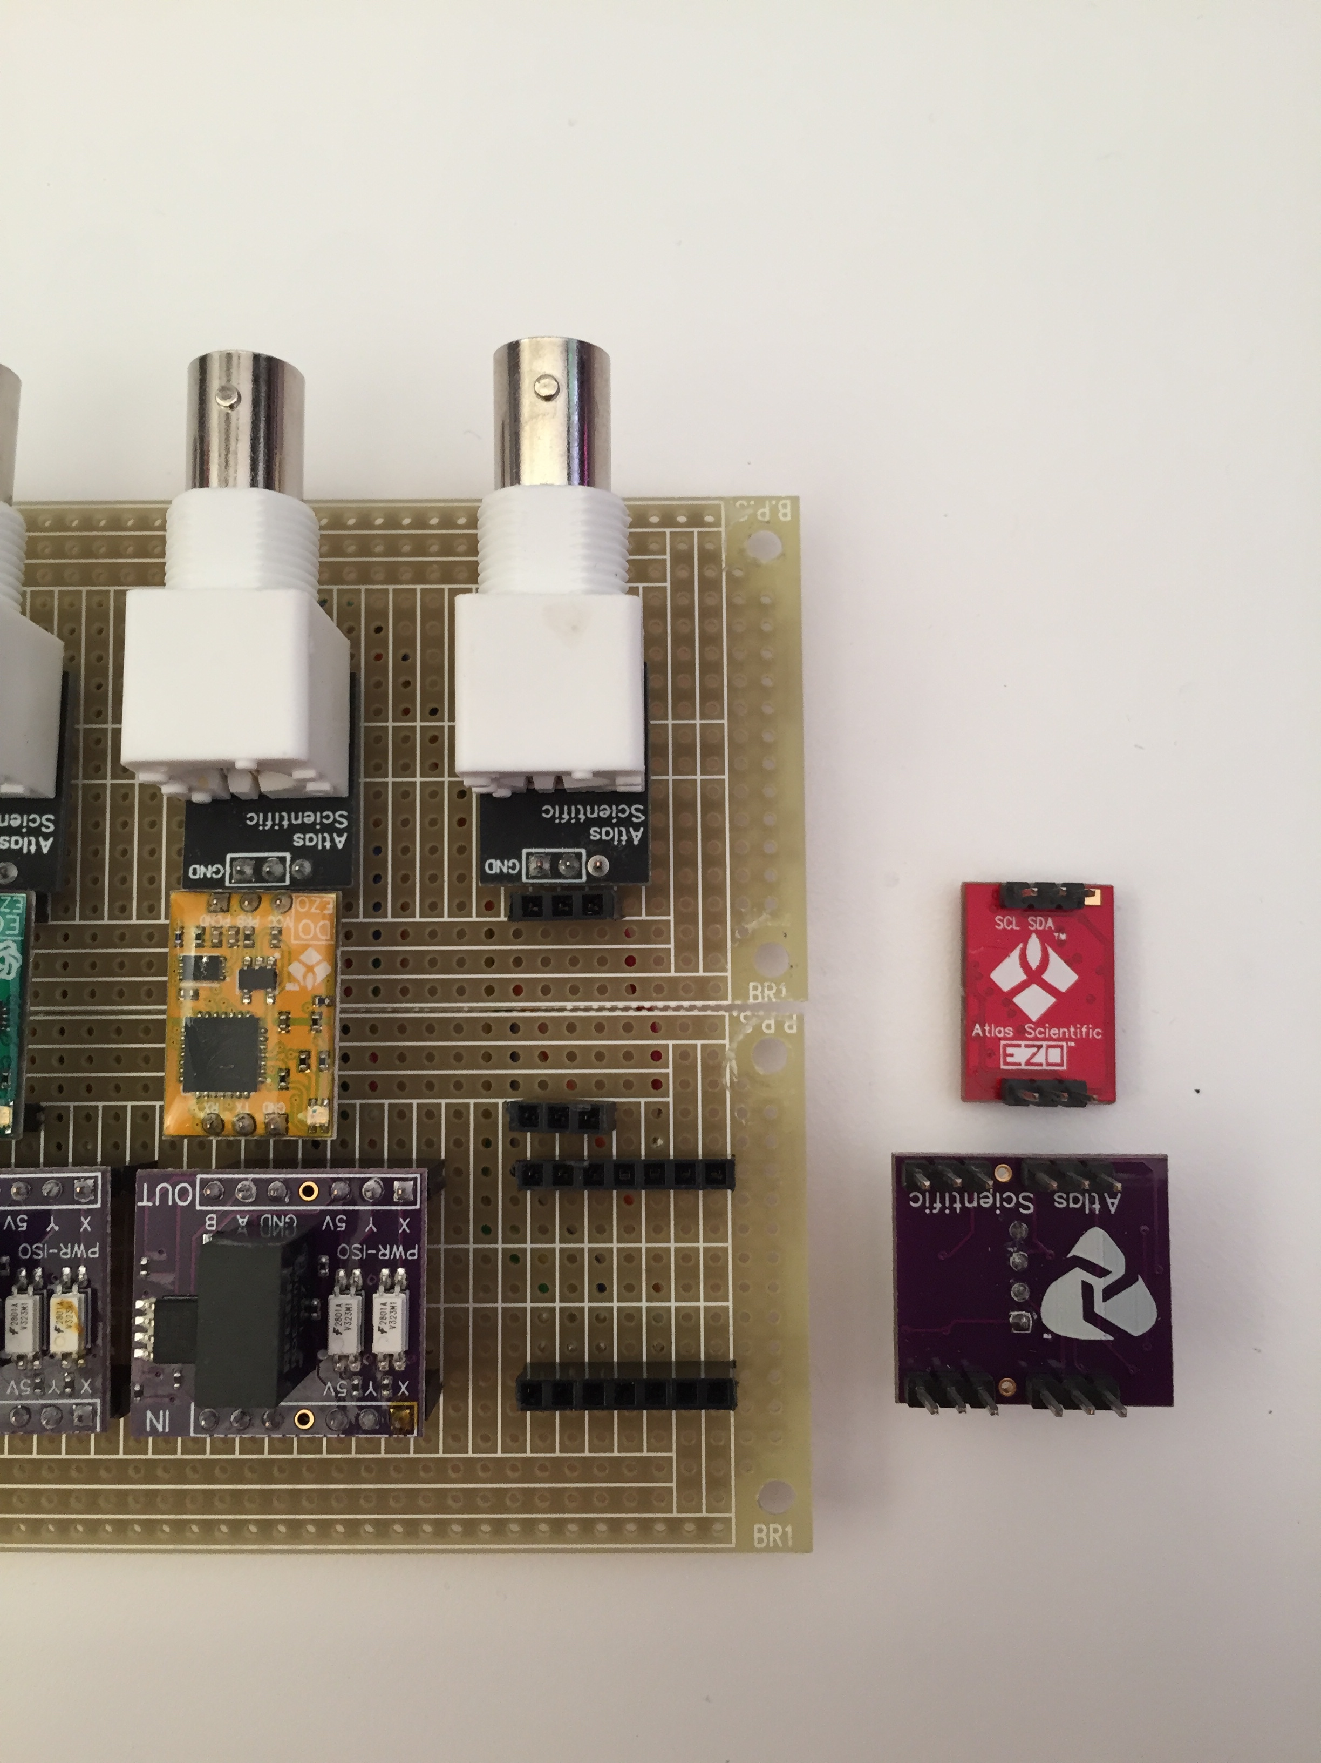Detail of headers and circuits/power isolators:

Underside and connections:

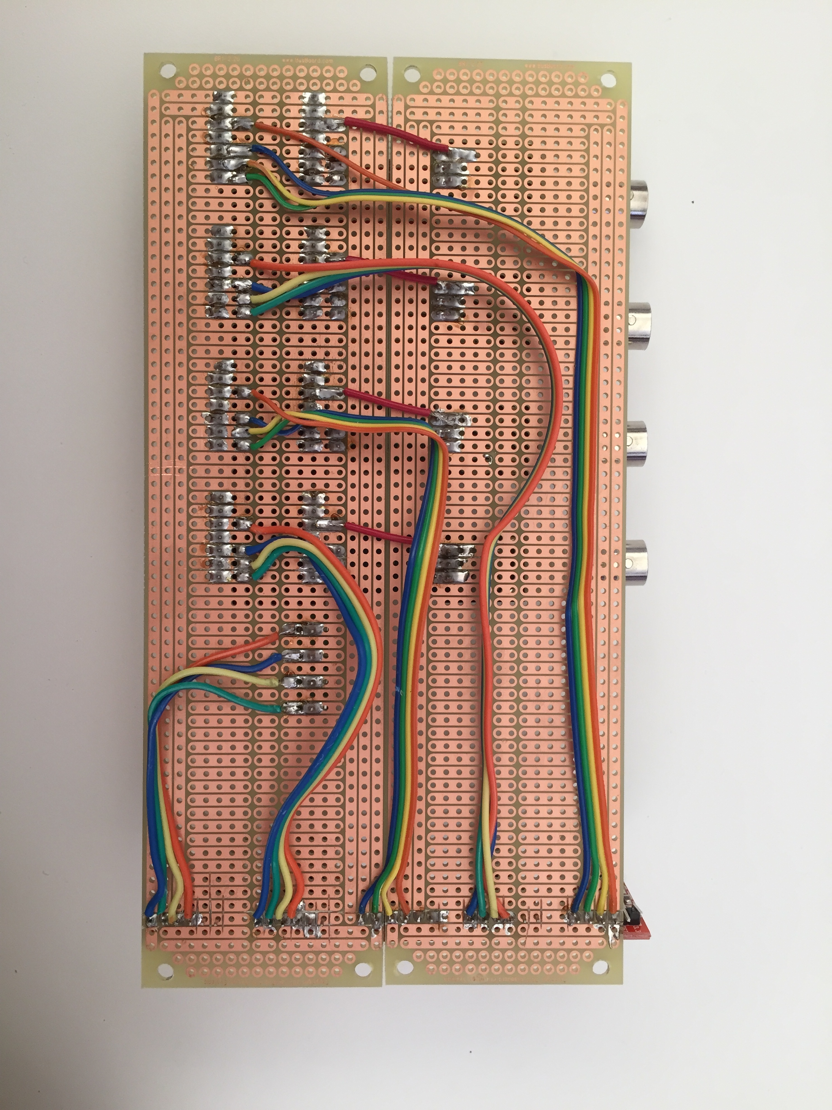

5V jumper wires

IN: B A GND N/C 5V Y X

RX TX

Serial:

5V

RX

TX

GND

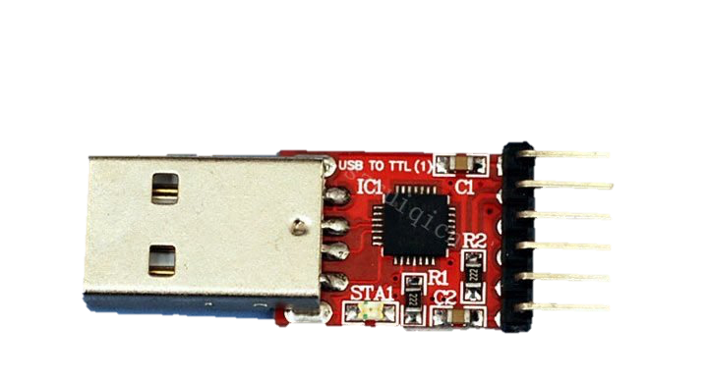

The pins of the USB-Serial converter are soldered onto the perfboard, and the wires are soldered directly into the converter’s pins

Note:

* The image above has been vertically flipped to make it easier to compare to the top view on the previous page.
* Different USB-Serial/TTL converter models have different pin positions, and some converters are labeled incorrectly (TX and RX pins inverted), so before committing to soldering the components, test and verify if the USB-Serial/TTL converter is properly connected to the Power Isolator/Circuit.  
  For reference, the USB-Serial/TTL converter model used in this example uses the CP2102 controller, and a link is provided in the reference section [11]
* The USB-Serial converters have been positioned along a vertical axis (purple line in the image above) simply because the USB hub used in this example has the USB ports aligned in such fashion. If a different USB hub is to be used, other arrangements of the USB-Serial converters can be made.
* Note that the traces had to be cut in order to solder the converters in this fashion.

2. Installing board and Raspberry Pi to waterproof box:

2.1. Laser cut the mounting plate:

The DXF file for the mounting plate is provided [16], and looks like the picture below:

Macintosh HD:Users:gkolotelo:Downloads:MountingPlate.pdf

Raspberry Pi

Sensor Board

Screw locations on waterproof box[12]

2.2. Screw standoffs to mounting plate:

Note:

The assembling method proposed is simply one of the many ways the Water Sensor Board can be put together.



Mounting Plate

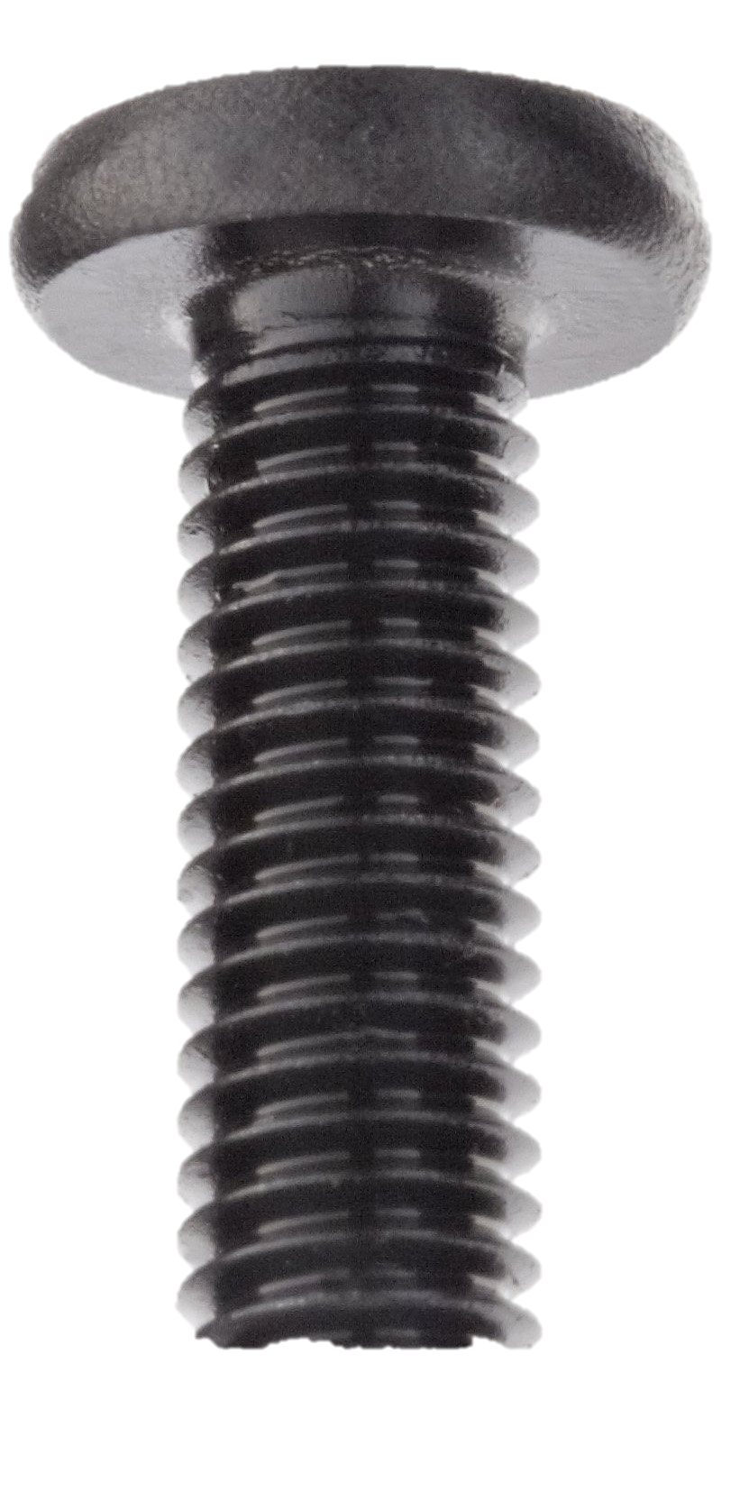

RPi

Standoffs

Perfboard

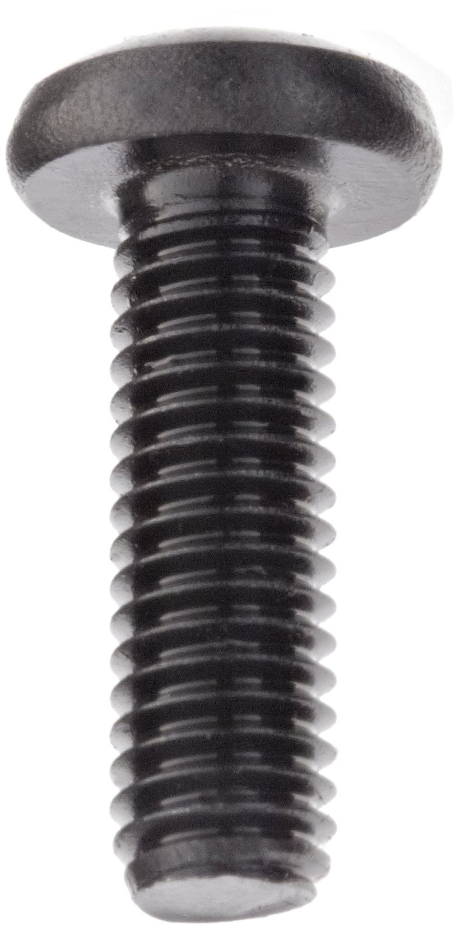

Screws to fix mounting plate on housing box (see notes)

2.3 Plug in cables and USB hub.

Plug in the Raspberry Pi power cord, the Ethernet cable, and the sensor’s probes to their respective BNC connectors and screw in the temperature sensor wires to the screw terminal.

Finally, plug in the USB-Serial/TTL converters to the USB hub, and plug the USB hub to the Raspberry Pi.

Notes:

* A hole had to be drilled in order to route the probe cables, power cord and Ethernet cable through, depending on the housing box chosen this might not be necessary.
* The standoffs are used to reduce stress on the jumper wires used under the perfboard, as well as to allow the mounting plate to be screwed in place before the perfboard, so as to allow access to the 4 screw holes (on this specific housing box).
* As mentioned above, for this specific housing box, the mounting place has to be screwed in place before mounting the perfboard, since the housing screws reside underneath the perfboard.

Raspberry Pi power cord

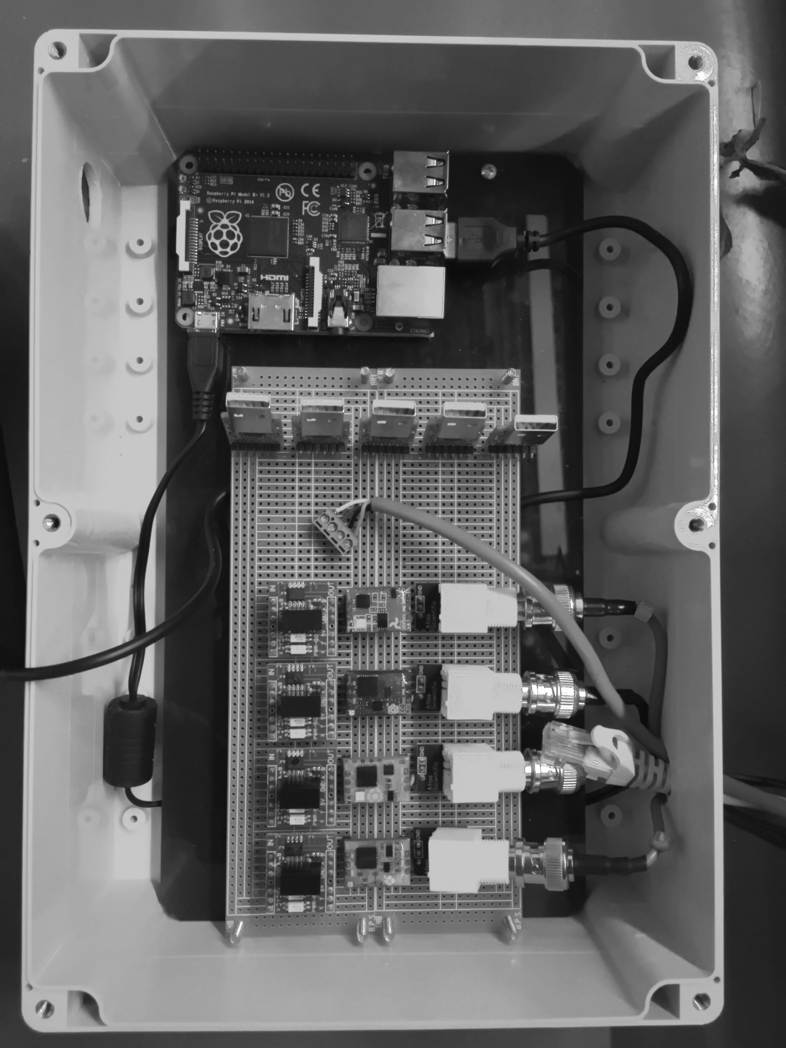Example:

Place where USB hub is located

USB hub plug

Probes connected

Temperature sensor screwed in

Hole drilled for wires

Ethernet cable disconnected

Ethernet jack

3. Deploying Water Sensor Board

After the board has been assembled it is ready for deployment, for that, follow the “Water-Air Board Deployment Guide”.

[1] <https://www.atlas-scientific.com/product_pages/probes/env-tmp-d.html>

[2] <https://www.atlas-scientific.com/product_pages/circuits/ezo_ph.html>

[3] <https://www.atlas-scientific.com/product_pages/probes/ph_probe.html>

[4] <https://www.atlas-scientific.com/product_pages/circuits/ezo_orp.html>

[5] <https://www.atlas-scientific.com/product_pages/probes/orp_probe.html>

[6] <https://www.atlas-scientific.com/product_pages/circuits/ezo_do.html>

[7] <https://www.atlas-scientific.com/product_pages/probes/do_probe.html>

[8] <https://www.atlas-scientific.com/product_pages/circuits/ezo_ec.html>

[9] <https://www.atlas-scientific.com/product_pages/probes/ec_k0-1.html>

[10] <https://www.atlas-scientific.com/product_pages/circuits/pwr-iso.html>

[11] <http://www.amazon.com/Zitrades-CP2102-Module-Download-Converter/dp/B00GWHRD82/ref=sr_1_6?ie=UTF8&qid=1420683741&sr=8-6&keywords=usb+serial+ttl>

[12] <http://www.raspberrypi.org/>

[13] <http://www.amazon.com/BUD-Industries-PN-1340-C-Polycarbonate-Length/dp/B005T7B7GA/ref=sr_1_9?ie=UTF8&qid=1420522821&sr=8-9&keywords=bud+industries+clear>

[14] <http://www.amazon.com/Solderable-BreadBoard-matches-tie-point-breadboard/dp/B003WLJZMI/ref=sr_1_13?ie=UTF8&qid=1420494300&sr=8-13&keywords=perf+board>

[15] <https://github.com/MIT-CityFARM/sensor-board>